**Syed, Ahmad Jamal (1929-2011)**

Syed Ahmad Jamal was a painter who promoted Abstract Expressionism as an artistic approach in Malaysia. As an art student, he was already drawn to the theoretical writings of Wassily Kandinsky and Paul Klee and his early interest in art drew him to the works of Emil Nolde, Kirchner and Max Beckmann. In one of his writings, he associated the Abstract Expressionist idiom as reflective of Malaysian independence, hailing Abstract Expressionism as an important artistic approach in Malaysia. His early works include, *Pohon Nipah* (1957), *Mandi Laut* (1957),*The Bait* (1959), *Chairil Anwar* (1958) and *Perhubungan* (1963). However, Syed’s significance to Malaysian artistic modernism was not only in the production and promotion of Abstract Expressionism but also in his curation of the Rupa dan Jiwa exhibition held at the ASEAN Museum of Art at the University Malaya in 1979. This exhibition inspired many artists to explore the possibility of using Malay and/or Islamic aesthetics in their art practice. Subsequently, Syed produced his G*unung Ledang* series that depicted the Gunung Ledang legend using images and symbols of Malay culture and nature. Syed had consistently used the *tumpal* or the triangle shape in many of his works as a symbol of stability, and harmony.

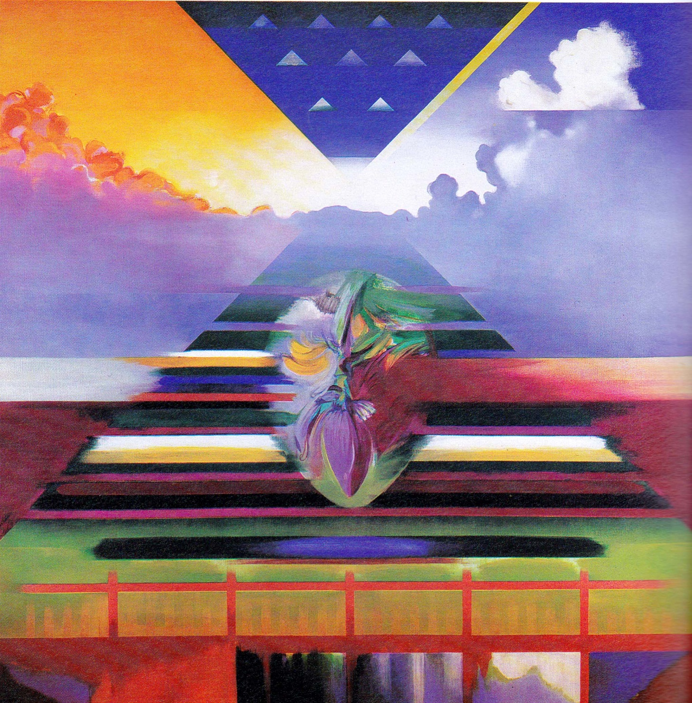

*Jantung Hati (1983), 199 x 199cm, acrylic on canvas, Puan Seri Dr Habibah Mohd Salleh Collection.*

(Image taken from *Syed Ahmad Jamal: Pelukis*. Kuala Lumpur: National Art Gallery, 2009. Permissions to be obtained.)

Syed Ahmad Jamal was born in Bandar Maharani, in Muar, Johor in 1929. He received his Malay and English primary and secondary education before attaining his formal arts education from the Chelsea School of Art (1951-1955), and then the Institute of Education, London University (1955-1956), the School of Art Institute Chicago (1963-1964) and finally at the University of Hawaii, Honolulu (1973-1974). His role in the Malaysian art world is expansive, having taught art at various levels and also serving as the head of the Art Education Department at Maktab Ilmu Khas in Cheras. He was appointed as the Chairman to design the arts syllabus whilst he was the Senior Officer at the Ministry of Education and also lectured at the Universiti Malaya Art Centre before being appointed as Director of the National Art Gallery (1983-1991).

Syed Ahmad Jamal has received many awards for his involvement in the fine arts. In 1987 he received the ASEAN Cultural Award for the Visual Arts and in 1995 he was awarded the National Art Award by the Malaysian Government. He was conferred the Panglima Jasa Negara(PJN) which carries the title “Datuk” in 1996 for his contributions in various fields of art and in 2009 and 2010, a major retrospective was held for him at the Malaysian National Art Gallery in Kuala Lumpur. On July 30, 2011, Syed Ahmad Jamal, died at his home at the age of 82 years.

**References and further reading**

---- (1975) *Retrospektif Syed Ahmad Jamal*. Kuala Lumpur: Balai Seni Lukis Negara.

---- (1987) *Senilukis Malaysia 57-87*. Kuala Lumpur: Balai Seni lukis Negara.

---- (2009) *Syed Ahmad Jamal: Pelukis*. Kuala Lumpur: National Art Gallery.

Jamal, Syed Ahmad. (1999) *Kunang-Kunang: Kenang-Kenangan Syed Ahmad Jamal Seniman Negara*. Ampang/Hulu Kelang: Dewan Bahasa dan Pustaka.

Jegadeva, Anurendra. (2006) *On and Off King's Road: 10 New Paintings by Datuk Syed Ahmad Jamal*. Kuala Lumpur: Petronas, 2006.